**IRANIAN SOCIETY OF PULMONOLOGY**

**Board of Directors**

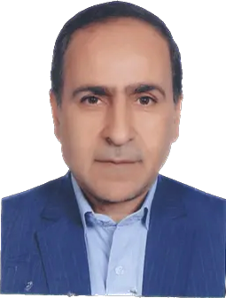

-Mostafa Ghaneei- Professor of Pulmonary Medicine- Baghiatollah University of Medical Sciences- President

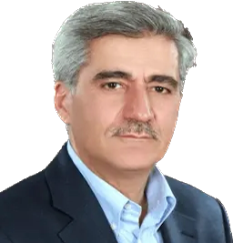

- Khalil Ansarin- Professor of Pulmonary and Sleep Medicine- Tabriz University of Medical Sciences-Director of International Program



Farid Rashidi- Associate Professor of Pulmonary and Critical Care Medicine- Tabriz University of Medical Sciences- Secretary of Association

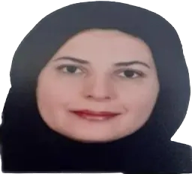

Mehrnaz Asadi Gharabaghi- Associate Professor of Pulmonary Medicine-Tehran University of Medical Sciences- Treasurer of Association

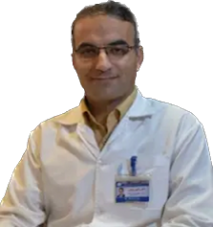

Ramin Sami- Associate Professor of Pulmonary Medicine- Isfahan University of Medical Sciences Director of Education Program

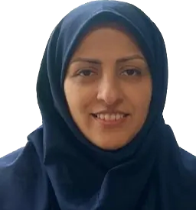

Hanieh Raji- Associate Professor of Pulmonary Medicine- Jondi shapour University of Medical Sciences Member of Association

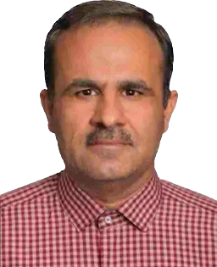

Tahmoores Niknam- Pulmonologist and Intensivist- ShiraZ University of Medical Sciences - Member of Association

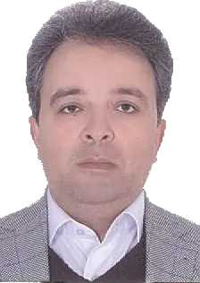

Alireza Kashefizadeh- Assistance Professor of Medicine- Shahid Beheshti University of Medical Sciences, inspector

**Chairs of Departments**

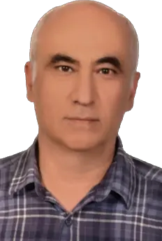

Babak Amra- Professor of Pulmonary & Sleep Medicine- Isfahan University of Medical Sciences- Director of Sleep disorders program

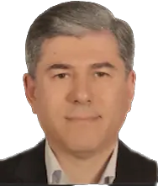

Seyyed Ali Alavi Foumani- Professor of Pulmonary Medicine- Gilan University of Medical Sciences- Director of ILD program

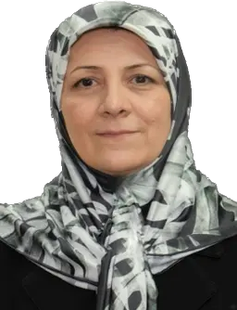

Katayoon Najafizadeh- Associate Professor of Pulmonary Medicine- Shahid beheshti University of Medical Sciences- Director of Lung Transplant program

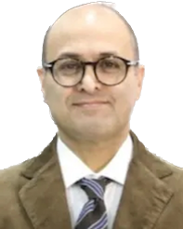

Arda Kiani- Associate Professor of Pulmonary Medicine- Shahid Beheshti University of Medical Sciences- Director of Interventional program



Ramin Sami- Associate Professor of Pulmonary Medicine- Isfahan University of Medical Sciences- Director of Airway diseases program

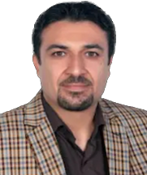

Mohammad Javad Fallahi- Assistant Professor of Pulmonary Medicine- Shiraz University of Medical Sciences- Director of critical care medicine program

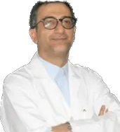

Alireza Eslaminezhad- Associate Professor of Pulmonary Medicine- Shahid Beheshti University of Medical Sciences- Director of Pulmonary FunctionTest program



Farid Rashidi- Associate Professor of Pulmonary Medicine- Tabriz University of Medical Sciences- Director of Pulmonary Vascular Diseases program

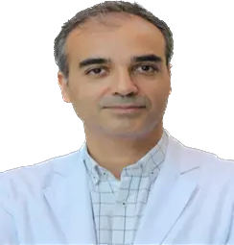

Mohsen Farrokhpoor- Assistant Professor of Pulmonary Medicine- Iran University of Medical Sciences - Director of lung cancer program

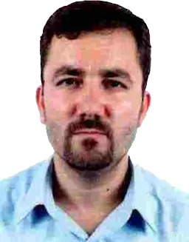

Mehdi Nadiri- Assistant Professor of Pulmonary Medicine- Tabriz University of Medical Sciences- Director of chest Ultrasound program