Multiple pulmonary lesions as the first manifestation of Behcet's disease

Guitti Pourdowlat1, Somayeh lookzadeh 1

1; Chronic Respiratory Diseases Research Centre, National Research Institute of Tuberculosis and Lung Diseases (NRITLD), Shahid Beheshti University of Medical Sciences, Tehran, Iran

A 17-years old boy was admitted due to chest pain, nonproductive cough and 8 KG weight loss for 3 months. He developed intermittent fever and dyspnea since 2 weeks ago. He did not have any past medical history. He had received oral antibiotics before admission with no improvement. In physical examinations he was stable and afebrile with mild crackles in both lungs. Pustular skin lesions on his face and upper extremities were detected. There were no furfure abnormal clinical findings. Routine laboratory tests revealed total leukocyte count 11800 cell per micro liter with neutrophil 72%, lymphocyte 24% and mix4%.ESR was 110 mm in first hour. Renal, liver function and electrolytes were within normal limits.

Chest radiograph (figure 1) showed normal cardiothoracic ratio and pulmonary artery with peripheral parenchymal opacities at the left lower lobe and CT scan(figure 2) was performed for patient which showed multifocal bilateral sub pleural consolidation with subtle pleural reaction.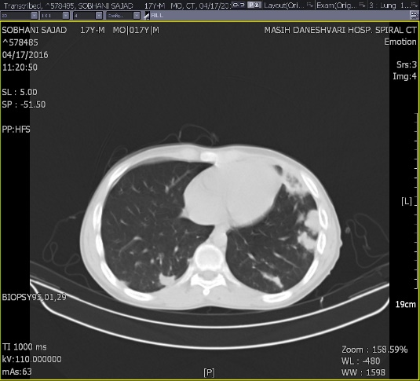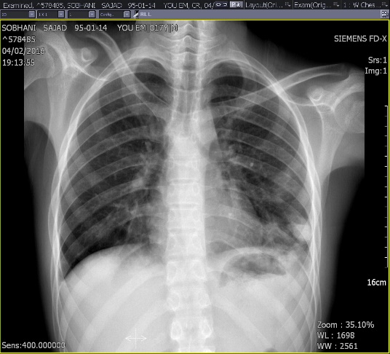

Figure 2

Figure 1

Serum immunological profile e.g.-P ANCA ,ACE,ANA, ANTI DS-DNA and RF were negative. NBT was normal. Serum galactomannan was not showed abnormal findings. Sputum culture for bacterial and fungal infection and sputum smear for AFB were negative. Based on CT scan and laboratory findings the patient underwent open lung biopsy

Histopathological examination at first biopsy with trans bronchial lung biopsy ( TBLB) revealed nonspecific parenchymal eosinophilic infiltration, therefore surgical lung biopsy performed and showed foci of infarct areas in lung parenchyma, thrombosis and occlusion of medium sized lung vessels; with recanalization and intra alveolar accumulation of hemosiderin-laden macrophage in some vessels (figure 3,4) .

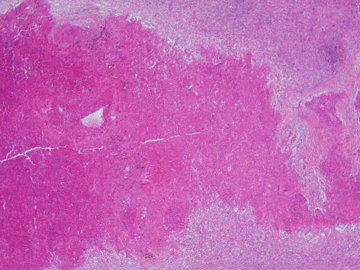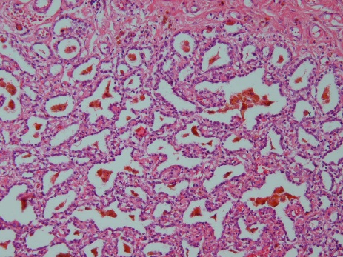

B

A

FIGURE 3 A.Pulmonary infarct B.Pulmonary hemorrhage(hemosiderin-laden macrophage)

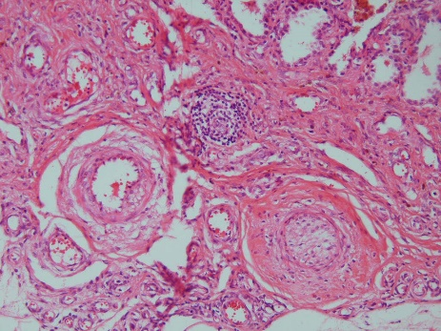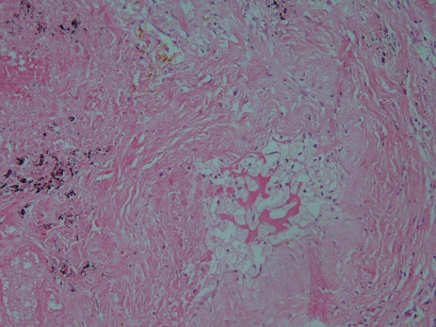

C

D

FIGURE 4 C.Pulmonary vessel thrombosis D.Pulmonary vessel thrombosis and recanalization.

During the admission patient developed oral ophtosis and subsequently pathergy test revealed positive. Eye examination showed bilateral optic atrophy. The diagnosis of Behcet’s disease was made on the clinical, radiological and histopathological findings. We started his treatment with pulses of methylprednisolone 1 gram for 3 days followed with one cyclophosphamide 750 mg IV infusion. After two weeks, chest radiograph (Figure 5) was repeated and it showed bilateral round lesions in both hilum which could be suggestive of pulmonary aneurysm with peripheral parenchymal opacities at left lower lobe. so pulmonary CT-Angiography (Figure 6) was performed and it revealed aneurysmal dilation of right and left lower lobe pulmonary artery branches with wall thickening of right and left main pulmonary artery which could be suggestive of vasculitis and also, some filling defects are showed in the right upper pulmonary artery branch which in favor of pulmonary emboli.

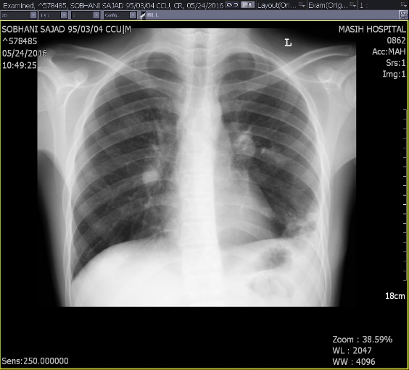

Figure 5

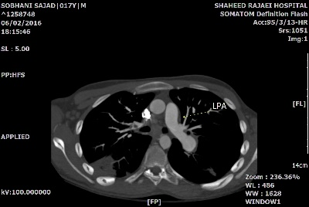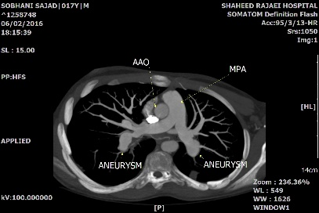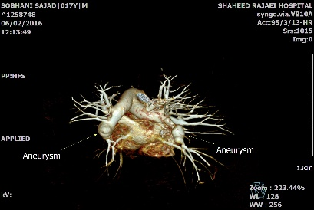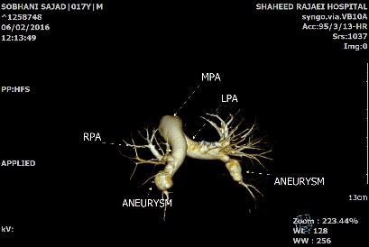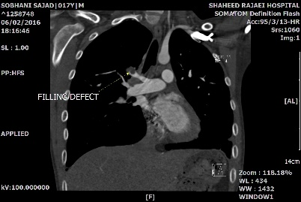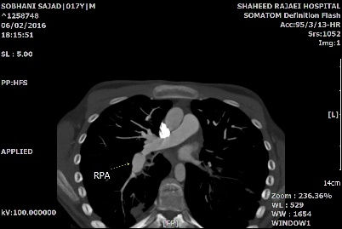

;

Figure 6; aneurysmal dilation of right and left lower lobe pulmonary artery branches with wall thickening of right and left main pulmonary artery which could be suggestive of vasculitis and also, some filling defects are showed in the right upper pulmonary artery branch which in favor of pulmonary emboli.

Behcet’s disease is a chronic ,inflammatory vascular disease with the clinical manifestations including genital and oral aphtha , ocular and neurological disease, skin lesions, pulmonary, urogenital and gastrointestinal involvement and arteritis(1-3) .the most clinical feature in patients with behcet disease is recurrent oral and genital ulcer with ocular disease(4). Pulmonary findings in behcet disease include pulmonary artery aneurysm, arterial and venous thrombosis, pulmonary infarction, pneumonia and pleural effusion (5)

Pulmonary artery aneurysm affected mainly young man which is presenting with dyspnea, cough, chest pain and hemoptysis. It carries a bad prognosis in patient with behcet disease .It may be single or multiple, unilateral or bilateral. Sudden hilar enlargement or the appearance of multi-lobular and round opacities on the chest radiograph can represent pulmonary artery aneurysm(5, 6).In vascular involvement, corticosteroid and cyclophosphamide are generally preferred .ANTI-TNF can be alternative. Anticoagulant shouldn’t be given in the presence of pulmonary arterial aneurysm because of the bleeding risk. Surgical intervention often is indicated for arterial aneurysm in patient with recurrent or massive hemoptysis (1, 5).

**Conclusion:**

Behçet's syndrome has various clinical manifestations and may present with incomplete clinical criteria, especially at the beginning of the disease, and with some atypical pulmonary manifestation. Therefor in high prevalence areas of Behçet's disease, this diagnosis should be considered.

1- Alpsoy E. New evidence-based treatment approach in Behcet's disease. Pathology research international. 2011;2012.

2- Davatchi F, Assaad‐Khalil S, Calamia K, Crook J, Sadeghi‐Abdollahi B, Schirmer M, et al. The International Criteria for Behçet's Disease (ICBD): a collaborative study of 27 countries on the sensitivity and specificity of the new criteria. Journal of the european Academy of Dermatology and Venereology. 2014;28(3):338-47.

4- Zeller L, Ling E, Abu-Shakra M. [TREATMENT DILEMMAS IN BEHCET'S SYNDROME]. Harefuah. 2016 Feb;155(2):92-3, 132-3. PubMed PMID: 27215119. Epub 2016/05/25. heb.

5- Alpsoy E, Zouboulis CC, Ehrlich GE. Mucocutaneous lesions of Behçet's disease. Yonsei medical journal. 2007;48(4):573-85.

Erkan F, Gül A, Tasali E. Pulmonary manifestations of Behçet's disease. Thorax. 2001;56(7):572-8.

6-Agha A, Bella AM, Assiri A-HM, Al-Hakami M. Can Behcet’s Disease Related Pulmonary Arterial Aneurysms be Completely Resolved? The open rheumatology journal. 2011;5:88.