**EDITORIAL GROUP**

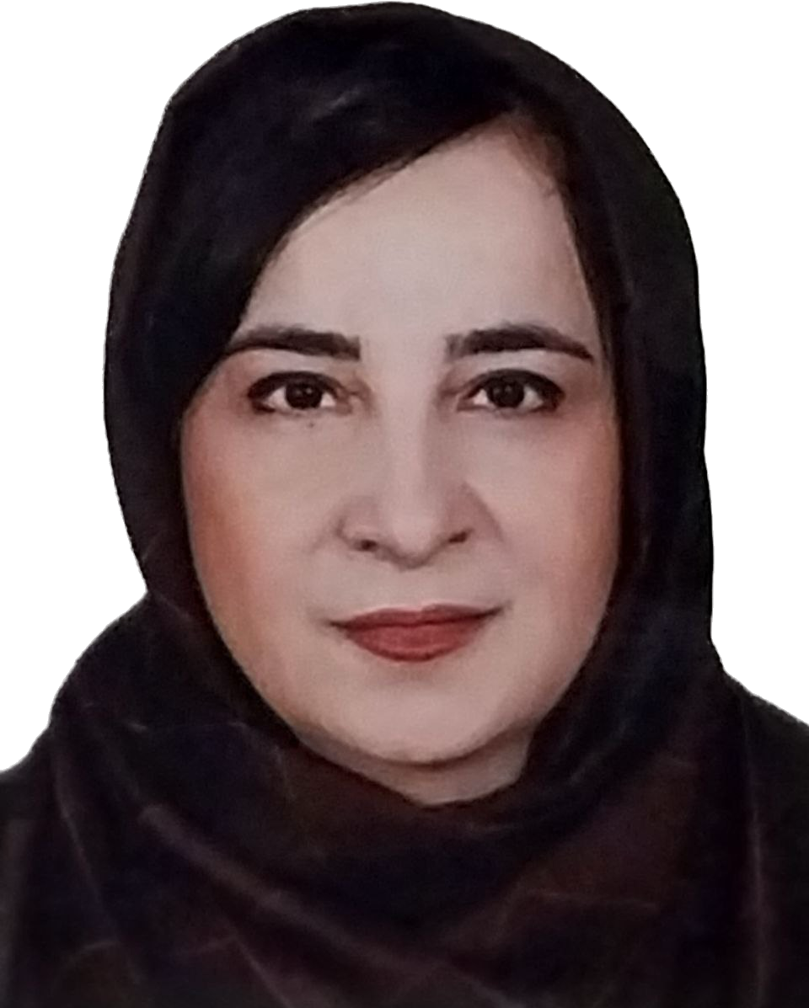**Chief Editor**

**Guitti Pourdowlat**. Pulmonologist, Chronic

Respiratory Diseases Research Center, National

Research Institute of Tuberculosis and Lung

Diseases (NRITLD), Shahid Beheshti University of

Medical Sciences, Tehran-Iran

*********

**Mehrnaz zolali**

Assistant editor

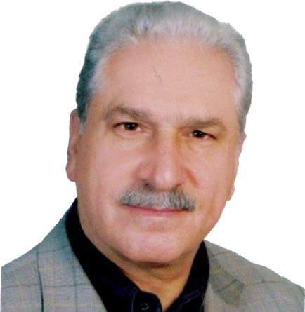

**Mohammad Reza Masjedi**

Professor of Pulmonary Medicine

, [Shahid Beheshti University of Medical Sciences, Tehran](https://scholar.google.com/citations?view_op=view_org&hl=en&org=7030147968151678976), Iran.

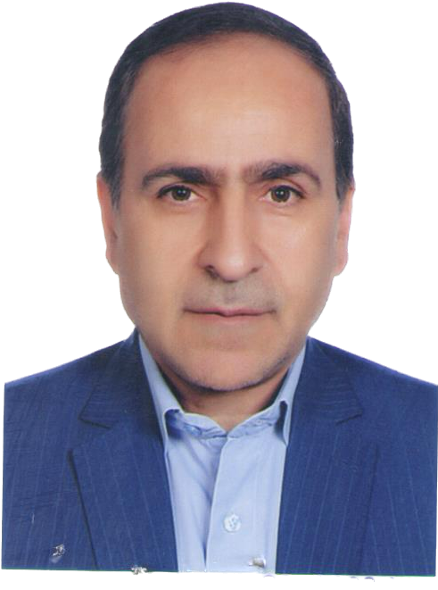

**Mostafa Ghanei**

Professor of pulmonary medicine.

Chemical Injuries Research Center, Baqiyatallah University of Medical Sciences, Tehran. Iran

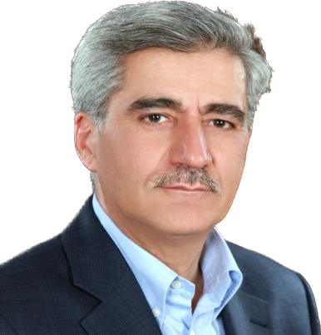

**Khalil Ansarin**

Professor in pulmonary Medicine, Head of Tuberculosis and Lung Disease Research Center, Tabriz University of Medical Sciences

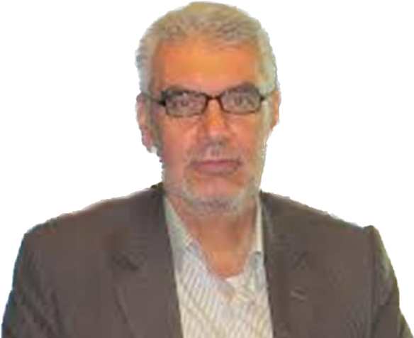

**Hassan Heydarnejad**

.

Pulmonologist, Department of Pulmonary Medicine.Shaheed Beheshti University of Medical Sciences and Health Services, TEHRAN-IRAN.

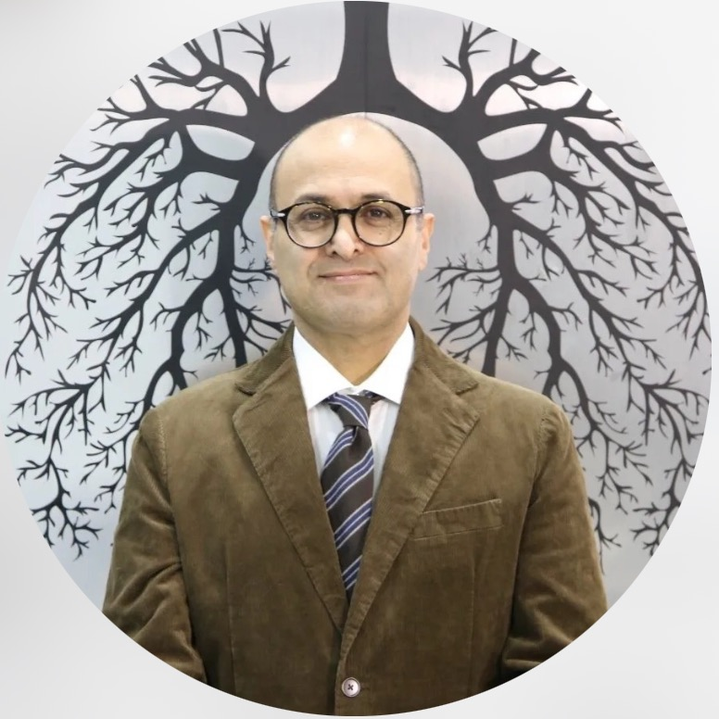

**Arda kiani**

Associate Professor at Internal Medicine Pulmonology, SBUMS

Head of Interventional Pulmonology and

Thoracic oncology division of Iranian Thoracic Society

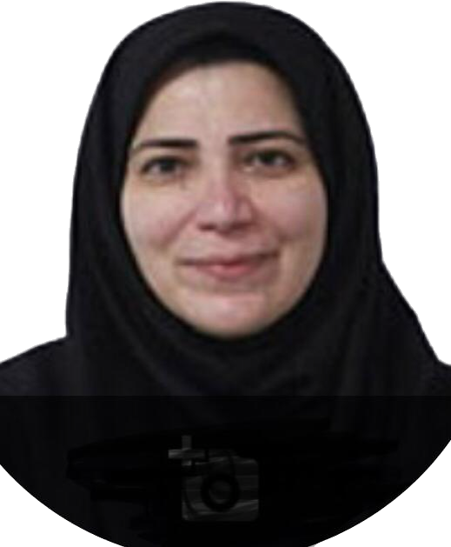

**Parisa Adimi Naghan**

Professor of Pulmoary and Sleep Medicine

Director of Sleep Flowship in Masih Daneshvari Hospital

,Shahid Beheshti University

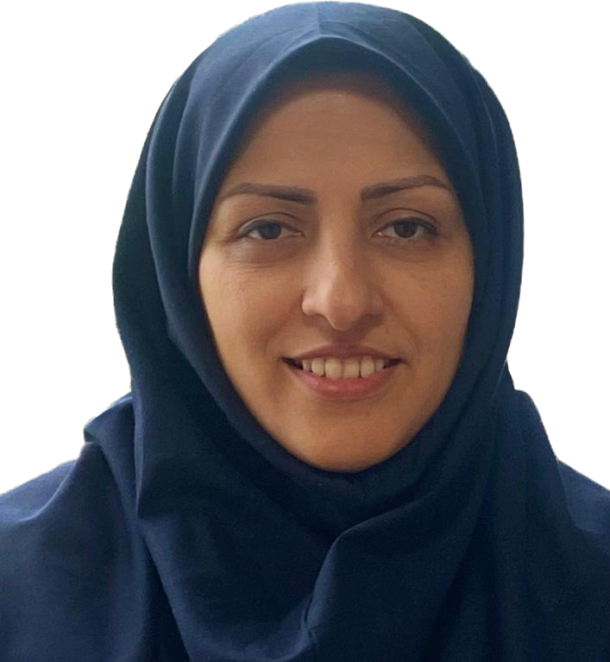

**Hanieh Raji**

Associated professor of pulmonoligy.

Ahvaz Jundishapur University of MedicalSciences

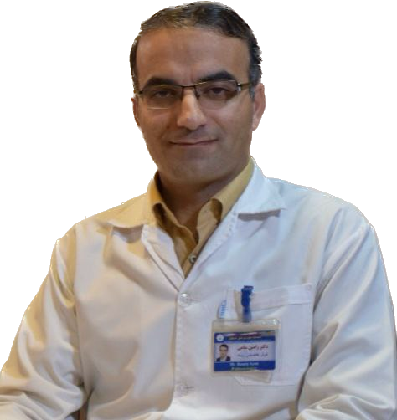**Ramin Sami**

Associate Professor - Department of Internal Medicine, School of Medicine, Isfahan University of Medical Sciences,Isfahan.Iran.

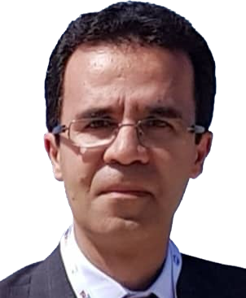

**Farid Rashidi**

Assistant Professor of Medicine Tabriz University of Medical Sciences

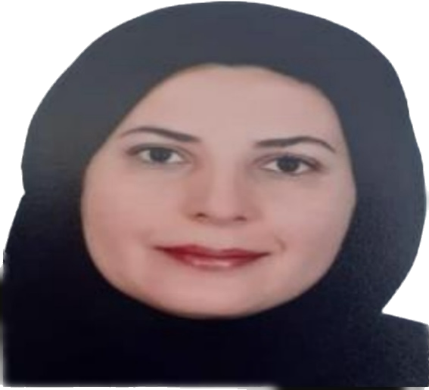

**Mehrnaz Asadi Gharabaghi**

Associate Professor of Respiratory [Medicine,Tehran University of Medical Sciences](https://scholar.google.com/citations?view_op=view_org&hl=en&org=16806557757143553874)

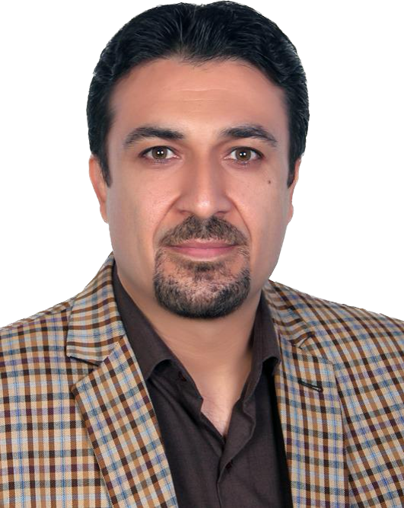

**Mohammad Javad Fallahi**

Assistant professor of pulmonogy

Department of internal medicine, shiraz university of medical science

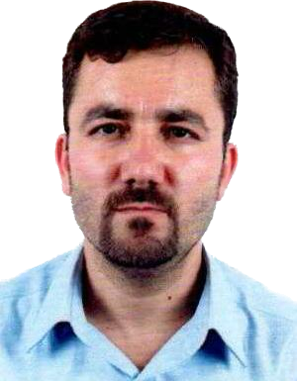

**Mehdi Nadiri**

Assistant professor of pulmolology ,internal medicine, intensivist ,

Tuberculosis and Lung Disease Research Center of Tabriz University of Medical Sciences, Tabriz, Iran

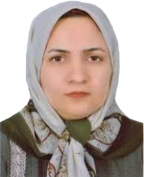

**FatemehAlsadat AghaeiMeybodi**,

Pulmonologist, Department of Internal Medicine  Shahid Sadoughi University of Medical Sciences, Yazd, Iran

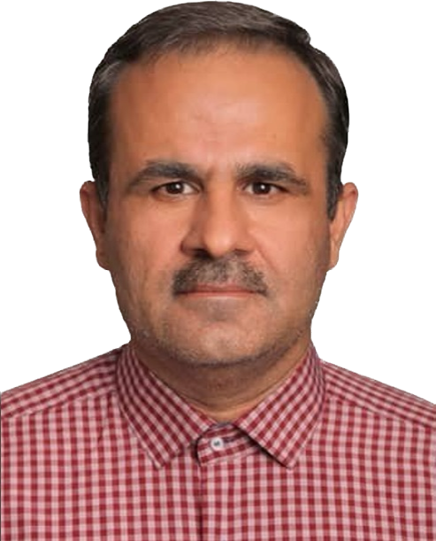

**Tahmooress Niknam**

Pulmonologist, Shiraz university of medical sciences, Abu- alicina hospital