Pleural Spindle cell tumors in a 70 years old woman 16 years after mastectomy for breast carcinoma

- MohammadHossein RahimiRad, professor of medicine, ( mohamadrahimirad@gmail.com)
- Akbar Sharifi, professor of medicine
- Shaghayeegh RahimiRad, general physician
Tabriz tuberculosis & Lung disease research center, Tabriz, Iran
Sarcomatoid carcinoma (SC) of the lung are rare, in one study consist of only 0.52% of all diagnosed cases of NSCLC [1]. They exhibit properties characteristic of both epithelial and mesenchymal tumors; they are classified into five major types by the World Health Organization (WHO), including pleomorphic carcinoma, carcinosarcoma, spindle cell carcinoma, giant cell carcinoma, and pulmonary blastoma.
Case presenting
On July 2018 a 70-year-old woman came to our clinic with complaint of dyspnea and right pleura tic chest pain. She has history of left mastectomy for adenocarcinoma in 17 November 2002. Then she has chemotherapy and left side radiotherapy for breast carcinoma. She was well for 16 years without any symptoms or metastasis. Because of this past medical history, we ordered a chest x ray (fig.1), which showed several large masses in right sided, and left side hyperlucency because of mastectomy. Since the patient was from a village with conventional sheep raising area, we first included echinoccus granulosa hydatosis as differential diagnosis. We immediately performed masses ultrasonography which revealed that masses are solid and incompatible with hydatosis. The chest CT showed large solid masses (Fig. 2)
The patient underwent medical semi rigid fibrotic thoracoscopy on which shows large solid with sharp borders, and forceps biopsy were taken.
On Light Microscopic examination showed fragments of pleural tissue with area of mesothelium cell hyperplasia and proliferation of spindle cells without nuclear atypia in lose fibrotic stroma, consistent with spindle cell tumor. We made consultation with another pathologist and asked for
Immunohistochemistry staining (IHC), according to last WHO recommendation.
IHC were positive for AE1/AE3 and vimentin and partial WT1, Carlitin , and P53. They were negative for estrogen receptor and mammaglobin. The final diagnosis of spindle cell sarcoma without breast component was made.
Discussion
SpCC of the lung is more commonly seen as a peripheral lesion which was consistent with the larg pleural-based masses on right side in present patient.
Our patien was diagnosed on biopsy by the appearance of heavily mitotic malignant spindle cells with hyperchromic nuclei and an absence of pleomorphic or giant cells
While diagnosis can be made with light microscopy, it is difficult to diagnose these tumors using small pleural biopsy samples [10]. The WHO (2015) recommended IHC testing to the known genetic abnormalities after light microscopic diagnosis.

IHC in SpC shows strong positive reactions for vimentin and cytokeratin and negative reactions for S100 protein, desmin, CD34 and α-smooth muscle actin.
Spindle cell tumors of the pleura constitute a rare group of neoplasms that remain among the most difficult to distinguish from one another because of their similar growth patterns of storiform or whorled type, and varying levels of differentiation, cellularity, and fibrous component. Differential diagnoses include sarcomatoid malignant mesothelioma (SMM) versus primary or metastatic sarcoma, spindle cell.
Our report is the first report of spindle cell in patient with breast carcinoma . Therefore, this case raises the question wetter there is a possible relation between spindle cell carcinoma and breast carcinoma itself or chemotherapy and radiotherapy, although more studies are needed to confirm this. What we CA say now , probably there is no relation to radio because it is in opposite side lung.
We present a case of a 60-year-old female with breast carcinoma who present with dyspnea and large pleura pulmonary masses with biopsy proven spindle cell carcinoma.
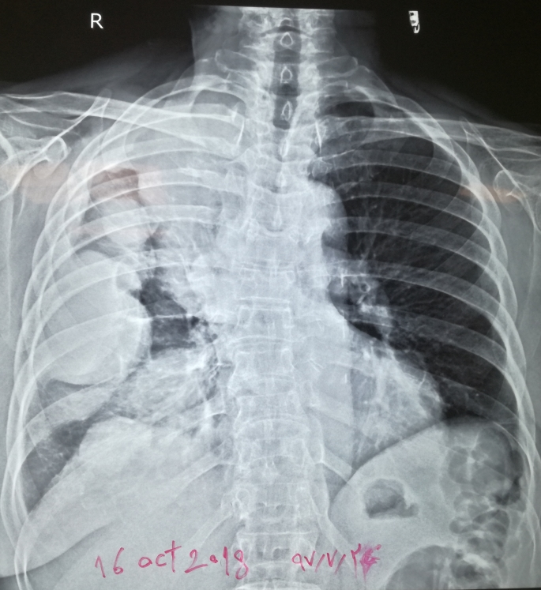
Chest x-ray shows lucent left hemithorax because of mastectomy, with large right pleural based masses

