A Rare case of Pulmonary Mucormycosis and Broncho-esophageal fistula in a patient with poorly controlled diabetes

Farid Poursadegh1,Safieh Shazdeh Ahmadi1,Zahra oskoueyan2,Mahnaz Mozdourian1,Fariba Rezai Talab1 ,Reza Bassiri1

1Lung diseases research center ,mashhad university of medical sciences, mashhad, iran

2Cardiology diseases research center ,Mashhad university of medical sciences,Mashhad, iran

**Corresponding author:**

Safieh Shazdeh Ahmadi MD,Lung diseases research center ,mashhad university of medical sciences, mashhad, iran

E-mail address: Shazdehahmadis4011@mums.ac.ir

**Abstract**

**Bachground** : Mucormycosis is a rare fungal infection caused by the Mucorales . This infection is mostly observed among those with poorly-controlled diabetes or immunodeficiency. The most common presentation of the infection among those with poorly-controlled diabetes is rhino-orbit-cerebral involvement . In this case report, we provide the history and outcome of a rare case of pulmonary mucormycosis in a patient with poorly-controlled diabetes who was simultaneously diagnosed with broncho-esophageal fistula.

**Case presentation** : a 32-year-old male with a history of poorly control diabetes. Over the months, he had complained of productive coughs and dyspnea, which had lately been joined by dysphagia. He also claimed to have lost a lot of weight (10 kg) during the previous three months . Computed tomography of the thorax revealed broncho-esophageal fistula between the left main bronchus and esophagus(figure1). He had a bronchoscopy the next day, which revealed necrosis and a broncho-esophageal fistula in the left main bronchus (LMB)(figure2). The patient underwent an endoscopy, which revealed erythematous mucus, a broncho-esophageal fistula, and necrosis, according to the GI consultation. A bronchial and esophagial biopsy showed typical hyphae with necrotic tissue, indicating mucormycosis(Figure 3). the patient's antimycotic medication (liposomal amphotericin) was started and prompt surgery consult . the patient however, passed away from massive hemoptysis.

**Conclusion:** We described a rare instance of pulmonary mucormycosis with broncho-esophageal fistula in a patient with poorly-controlled diabetes. The rarity of this combination highlights the associated diagnostic and treatment hurdles. Early detection, antifungal medication, as soon as possible surgical debridement of involved tissues, and a multidisciplinary approach could improve patient outcomes.

**Keyword:** broncho-esophageal fistula ; case report ; mucormycosis.

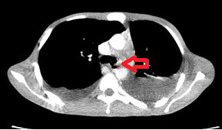

Fig.1 Computed tomography of the thorax revealed bronchoesophageal fistula between the left main bronchus and esophagus

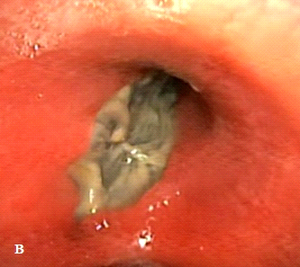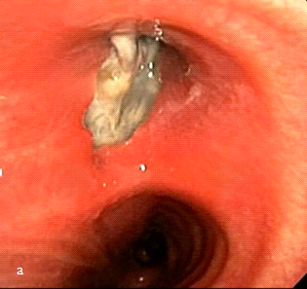

Fig.2 flexible bronchoscopy examination showing bronchoesophagial fistula and necrotic tissue in the proximal left main bronchus

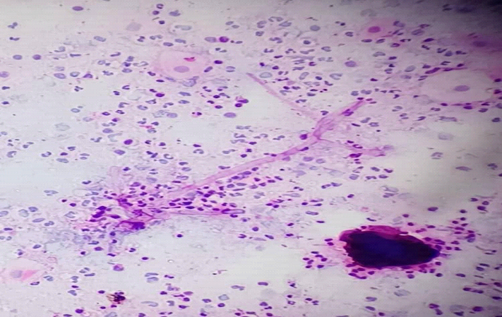

fig.3 bronchoscopic biopsy histology specimen shows ; many fungal nonseptate hyphae and thin wall upon staining with H&E.

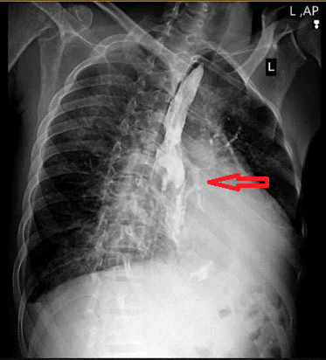

fig .4 barium esophagram showing an abnormal flow of the contrast to the left main bronchus with an apparent left contrast bronchogram ( red arrow )